2015-16
Mason High School Athletics

Dear Comet Fans,
Corporate Partnership Opportunities

It is an exciting time at Mason High School as the Comets enter another school year as a member of the Greater Miami Conference and look to possibly obtain our 7th straight All-Sports Trophy. A Division I member of the Ohio High School Athletic Association, Mason High School athletes and coaches continue to rewrite the record books and establish a new standard of excellence in interscholastic athletics. From fall to spring, Mason High School athletes work tirelessly on and off the field to achieve excellence for themselves, their teammates, their classmates, and their community.

Located in one of Cincinnati’s best suburbs, Mason High School is on pace to become the largest single high school in the state of Ohio over the next few years and the Mason High School Athletic Department has worked diligently to keep up with the growing student population. In an effort to increase student athlete opportunities, Mason Athletics has added additional middle school, freshman, and junior varsity level teams to existing programs in recent years. These additions bring the total number of programs to 26. These opportunities provided over 2,500 roster opportunities in more than 26 sport programs to student athletes in grades 7 through 12 during the 2013-14 school year.

Mason Athletics has reached out in recent years to invite members of our local business community to join the Mason Athletic Department family by becoming corporate partners of the Mason Comets. This partnership is intended foster the lifelong friendships, lessons, and values which interscholastic athletics provide, while helping our corporate partners cultivate and build relationships with both our school and local community.

With that in mind, I would like to thank you for taking the time to consider joining the Mason Athletics family and I hope you find the enclosed information beneficial and informative. Please feel free to contact me if I can assist you in any possible way. You can reach me at 513-398-2513 or by email at stemples@mason.k12.oh.us.

Enclosed you will find information on how your business can become part of the Mason Athletic family!

GO COMETS!

Respectfully,

Scott Stemple
Athletic Director
Mason City Schools

Mason Athletics and Overview
General Information
Community Population 31,039
District Student Population 10,879
High School Student Population 3,500
Total Number of Sports Teams/Programs (9-12) 65/26
OHSAA Classification AAA/Division 1
Athletic Conference Affiliation Greater Miami (GMC)
Approx. Visitors to Mason Athletic Facilities 70,000 annually
Events Hosted Annually by Mason High School (Approximately) 150
Students Participating in Extracurricular Activities & Athletics 90%
Facility Information
Dwire Field at Atrium Stadium (Football) 6,800 seat facility
Mason Middle School Arena (Boys Basketball & Wrestling) 2,800 seat facility
Mason High School Gymnasium (Girls Basketball, Volleyball, & Wrestling) 950 seat facility
Multi-Purpose Field (Soccer, Lacrosse, Football, & Camps) 1,200 seat facility
Natatorium (Swimming & Diving) 800 seat facility
Softball Stadium 600 Seat Facility
Baseball Stadium 250 Seat Facility

Mason High School annually hosts OHSAA Sectional, District, & Regional Tournament Events
Mason High School Athletic Department
Individual Sponsorships

Football Scoreboard Panel (50.5”x72”)
$2000/year – minimum 2 year agreement

LED Full Color Display Advertisement (17’ x 10’)
Full Advertisement Color Logo Display & Advertisement
$800.00

Arena Center Basketball Scoreboard Panel (24”x36”)
$700/year for one year

Arena Corner Basketball Scoreboard (20.5”x34”)
$600/year for one year

Baseball and Softball Scoreboard
Currently Unavailable

Multi-Purpose Field and Natatorium Scoreboard
$500/year for one year

Fence Banner (4’x6’)
$500/year for one year – Football Stadium & Track*
$500/year for one year – Multi Purpose Field**

*Fence banners will be displayed at varsity football stadium during fall and in the spring during track and field season.

**Fence banners will be displayed at the Multi Purpose Field during the fall & spring seasons.

All banners will be removed during the winter season.
10% discount will be given to multiyear agreements paid in full upon signing of agreement.
Mason High School Athletic Department
Individual Sponsorships cont.

Media Related Advertising

Football Scoreboard Board Electronic Logo Advertisement - $250
Athletic Program Advertisement
1/8 page - $100.00
¼ page - $160.00
½ page - $250.00
Full page - $450.00
Inside Front / Back Cover - $600.00
Inside Front / Back Cover with Color - $700.00
Center with Color - $850.00

Website Advertisements on www.gomasoncomets.com
(150 pixels x 90 pixels)
Logo Advertisement - $250/year for 1 year
Logo Advertisement with link to corporate website - $350/year for 1 year

Custom Packages
Custom packages may be created to best fulfill the needs of each corporate partner. Packages may include any of the above items and additional items such as:

Public Address Announcements
On site Promotional Nights at athletic events
On field recognition of corporate sponsors
Terms & Conditions
- All agreements shall end on July 1st of the agreed upon school year unless otherwise agreed upon.
- A 10% discount will be given to multiyear contracts paid in full at contract signing.
- Mason City Schools shall pay for initial signage. Changes to signage after installation shall be paid for by corporate partner.
- Corporate partner is responsible for providing all artwork.
Mason Athletics Signage Opportunities
Mason Middle School Arena
(Boys Basketball & Wrestling Tournaments)

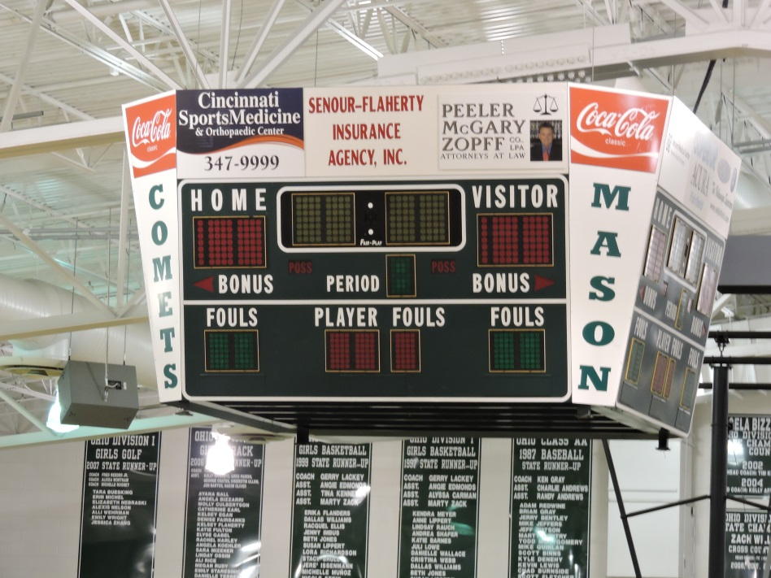

Center Score Board

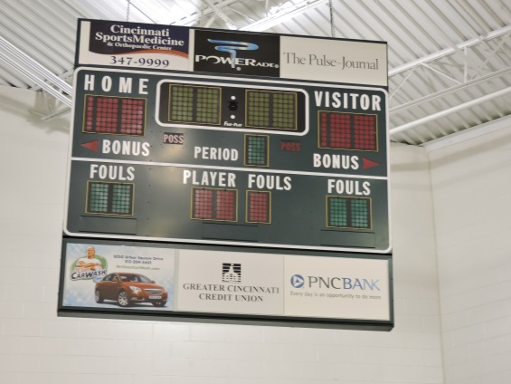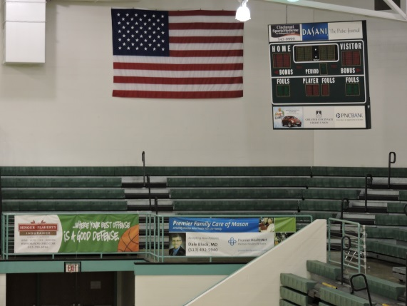

Corner Score Board Arena Rail Banner

Mason Athletics Signage Opportunities
Dwire Field at Atrium Stadium (Football and Track & Field)

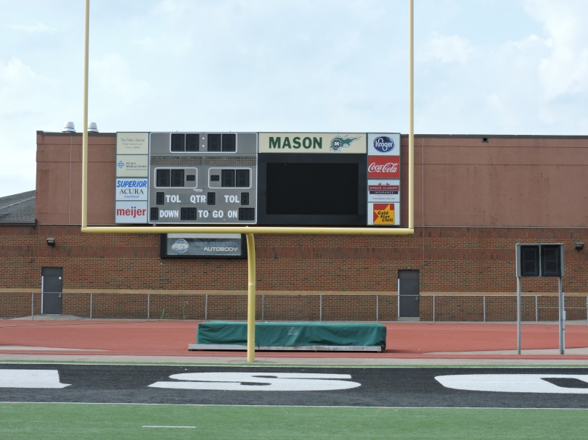

Football Scoreboard with fence banner space below

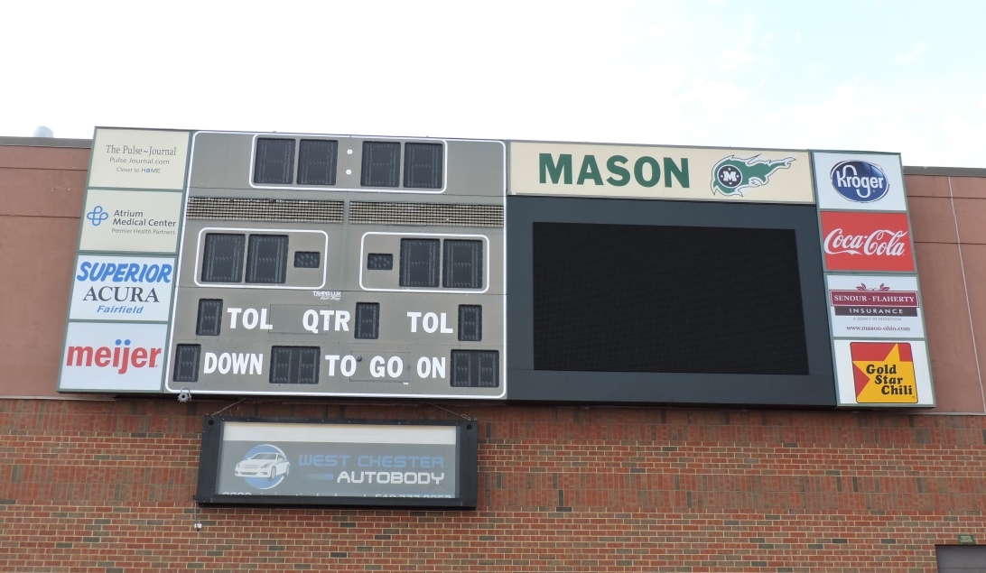

Football Scoreboard
Mason Athletics Signage Opportunities
Multi Purpose Field
(Boys & Girls Soccer and Lacrosse)

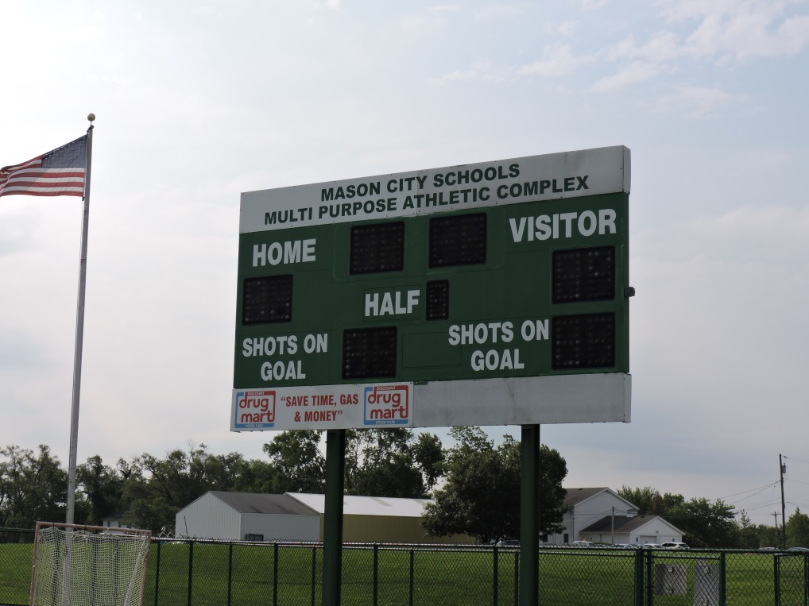

Multi Purpose Scoreboard Panel

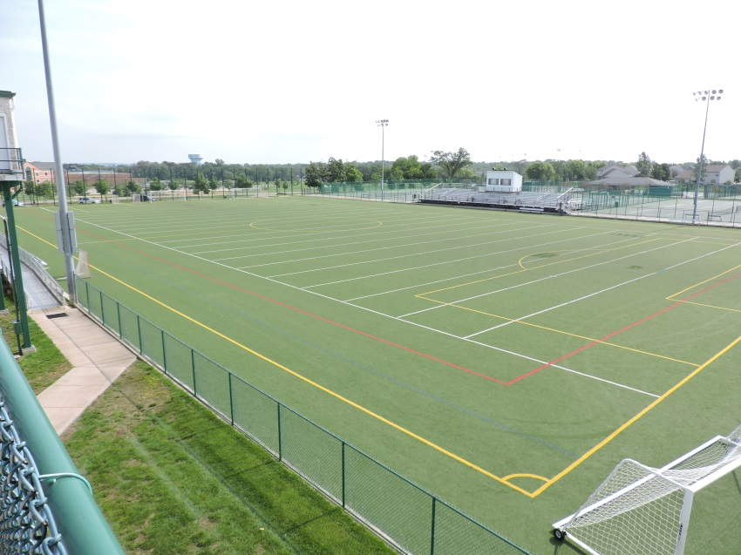

Multi Purpose Field Overhead View
Mason Athletics Signage Opportunities

Softball Field

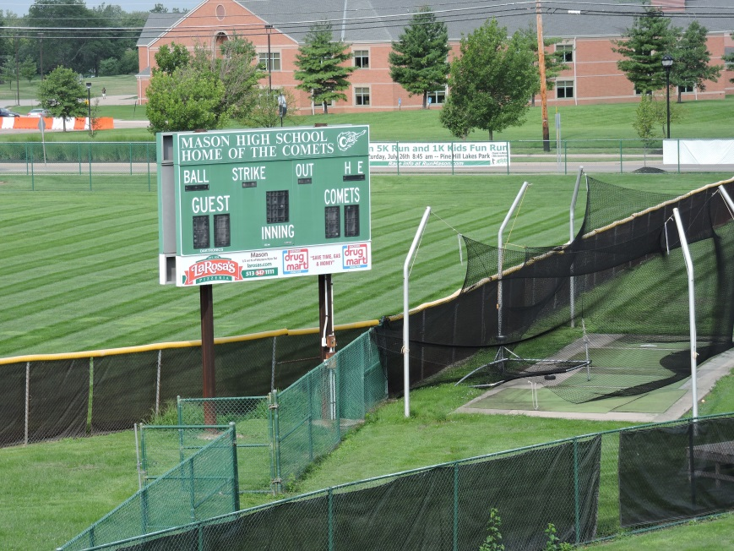

Baseball Field

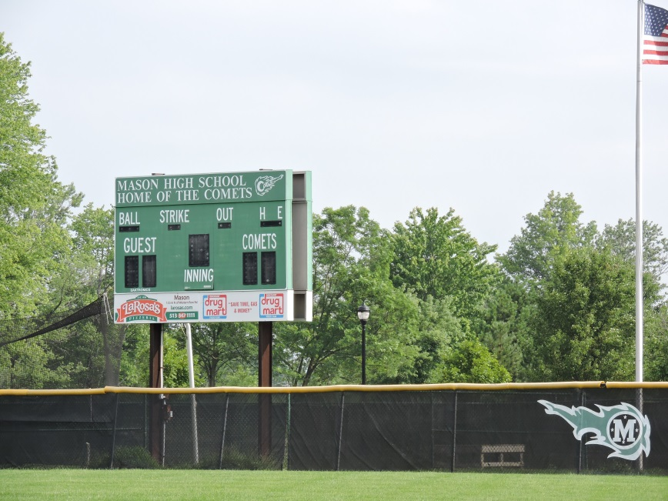
Contact Information

Mason High School Athletic Department
6100 S. Mason Montgomery Road
Mason, Ohio 45040
513.398.2513 (Office)
stemples@masonohioschools.com

